Work Queue = Case List
• A work queue is a list of cases to be worked by a process.
• A process will iterate through the queue cases in sequence.
• After working a case a process will update the queue with a result.
• Queue data is used to measure process performance and for generating MI (Management Information).

A process is unlikely to be able to complete every single case and some will be identified as exception cases.
Most exception handling should be done at process (or component) level. Business objects
can contain exception handling but in general they should be kept as simple, reusable pieces
of logic.

If attach stage throws the below error at the time of a fresh run then provide the process name
NAVIGATE: 'Attach' Process: 'Chrome Attach Excpetion' Subsheet: 'Action 1' ERROR: Internal : Failed to perform step 1 in Navigate Stage 'Attach' on page 'Action 1' - At least one of window title and process name must be specified

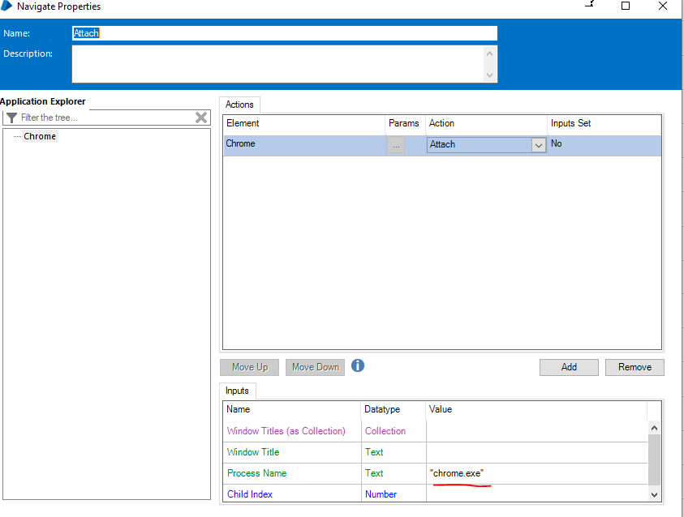

If we do not detach manually, then during attach stage at the time of second run (assuming app was already launched because of navigate stage) we get the following error
NAVIGATE: 'Attach' Process: 'Chrome Attach Excpetion' Subsheet: 'Action 1' ERROR: Internal : Failed to perform step 1 in Navigate Stage 'Attach' on page 'Action 1' - Already connected to an application

For the above step, I however if you get the below error then there is something wrong with the title. Tested with calculator/notepad/chrome and IE.
NAVIGATE: 'Attach' Process: 'Chrome Attach Excpetion' Subsheet: 'Action 1' ERROR: Internal : Failed to perform step 1 in Navigate Stage 'Attach' on page 'Action 1' - Target application could not be identified
Need to specify the window title("Untitled - Notepad"), chrome ("Google - Google Chrome"), IE("MSN India | Hotmail, Outlook, Skype, news, photos & videos - Internet Explorer") . Not necc to open apps via bp for attaching

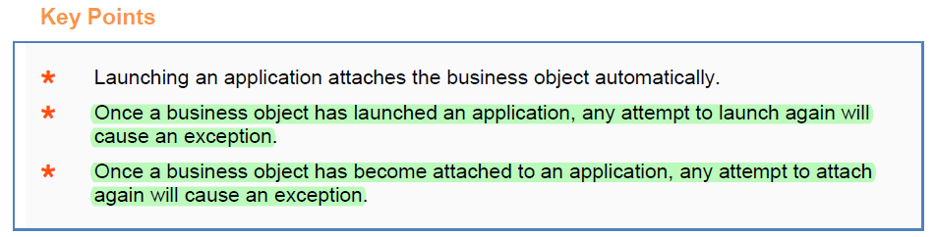

For chrome, use accessibility mode to spy on the Tab Title and extract window text
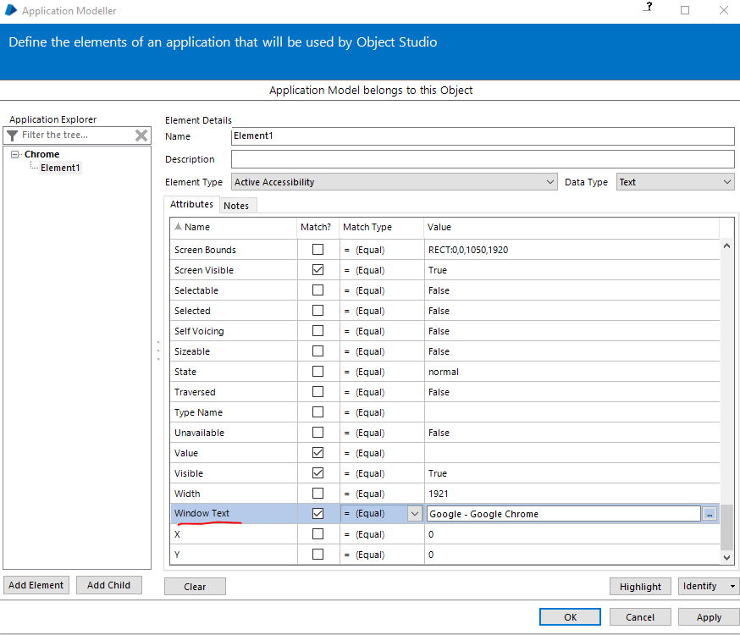

Same for IE. Spy the topmost IE bar and not the inside tabs
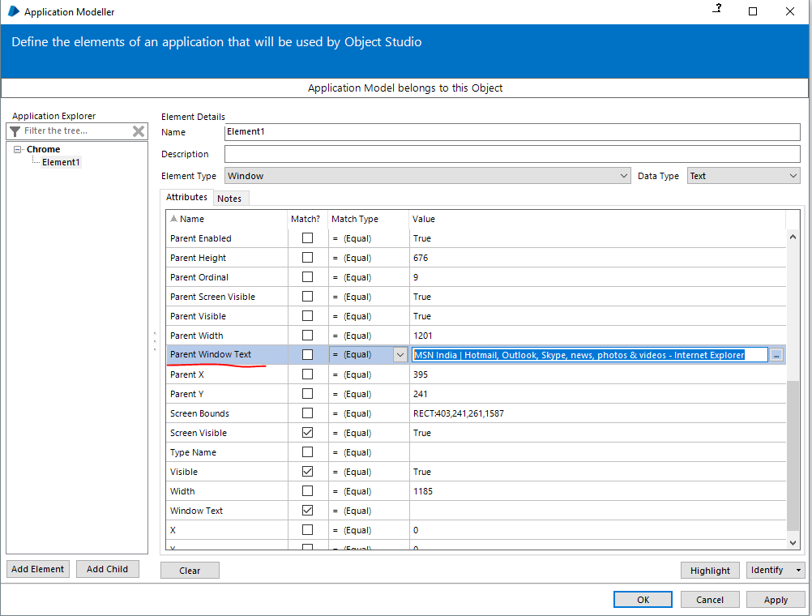
For IE/chrome – 4 spying modes will be shown. For calculator app, 3 modes will be shown
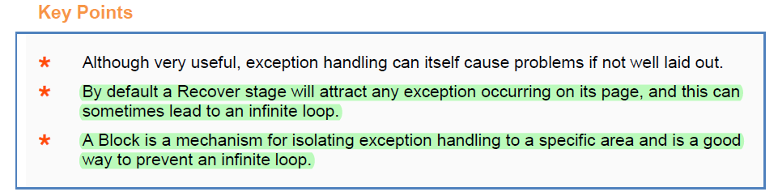
Sometimes we can make checks to avoid scenarios where an exception might occur.
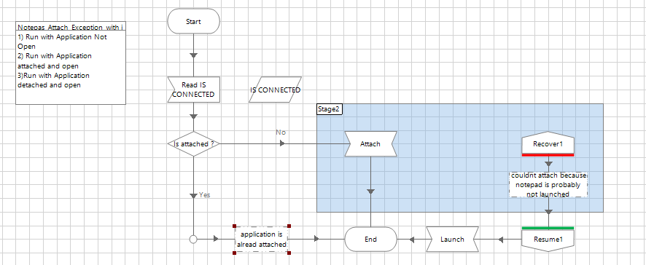
Code Stage : (Tip)
In Code stage, if we add inputs and outputs, then we should not redeclare/initialize it in the code window. Else it will give a compilation error similar to this
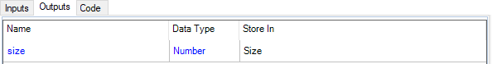
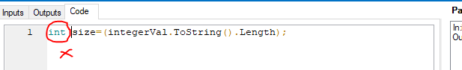
Page | Stage Name | Type | Action | Description | Repairable
Action 2 | Code1 | Error | Validate | Compiler error at line 1: A local variable named 'size' cannot be declared in this scope because it would give a different meaning to 'size', which is already used in a 'parent or current' scope to denote something else | No
Business Rules :
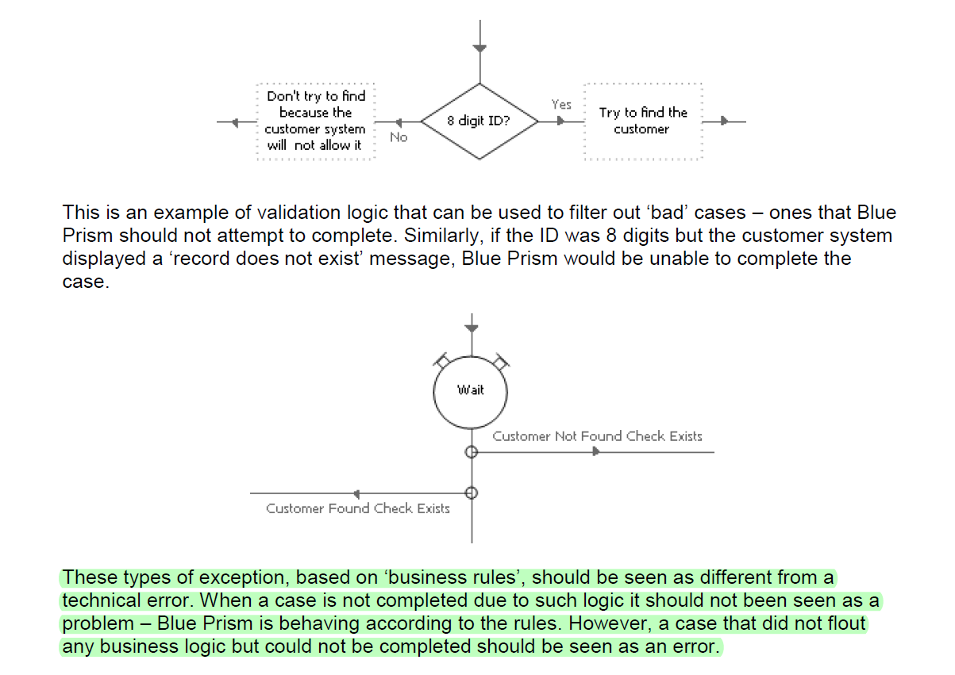
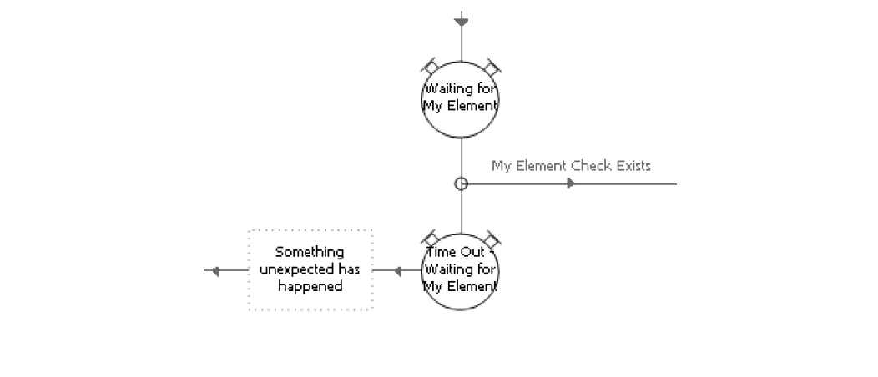
The above code is much better in dealing with application problems

Internal Exception:-
‘Internal’ is the type of exception that isn’t generated by an exception stage. The important thing to remember is that the internal type is an exception Blue Prism itself generates 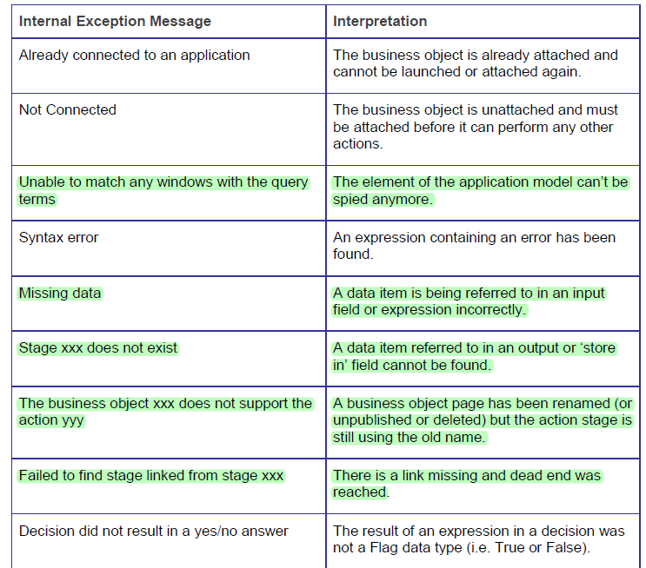
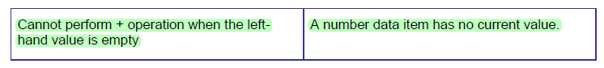

Work Queues -

1.10 Get Next Item
This action gets the next item to be worked from the queue, returning its details and locking it so no other case can work it. Items with higher priorities (lower numerical value) are processed first. Where the priority is the same, the next item is the one that has been in the queue the longest, is not already locked, and is not already completed. The Item ID returned is used to make further calls to update the work status for that item. It may be empty, in which case there are no items available. This can mean either a) the queue is empty, or b) the queue is not running. This mechanism can be used to cleanly stop all processes working a particular queue at the end of the next case. Items that have a 'deferred' time set will not be returned unless that time has been reached.

Endpoint:
An item is retrieved from the queue, if available
Parameter | Direction | Data Type | Description
Queue Name | In | Text | The name of the queue to add items to
Key Filter | In | Text | Optionally, a key value to filter by. Only items with this key value will be considered.
Tag Filter | In | Text | Optionally, a tag mask to filter by. This can consist of any number of tag searches - each term can be separated by a semi-colon and they are all applied to the search (ie. they are AND'ed terms not OR'ed terms). For example, "Account: Joint; -Balance: Overdrawn; Card: *Visa*" will include any items which match all the terms, ie. every item must have an 'Account: Joint' tag applied, no item can have a 'Balance: Overdrawn' tag applied, every item must have a tag applied which starts with 'Card: ' and then contains the text 'Visa'.
Item ID | Out | Text | The ID of the item retrieved - empty if there are none available.
Data | Out | Collection | The data associated with the item - a single collection row.
Status | Out | Text | The status of the item.
Attempts | Out | Number | The number of attempts already made to work this item.
If it’s invalid ID we generally throw an Exception of type “Data Exception” with message “Invalid ID”
If it’s a person under 18 years on whom the case must not be worked on then we mark it as “Business Exception” with message like ”Juvenile Case ”

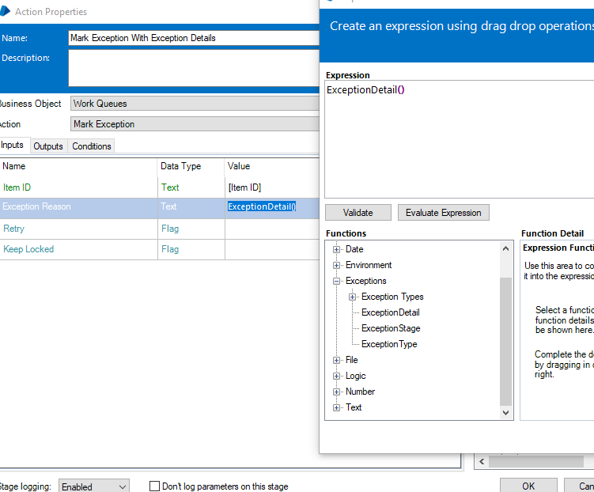

The exception functions can only be used in between recovery and resume stage else they will throw an exception
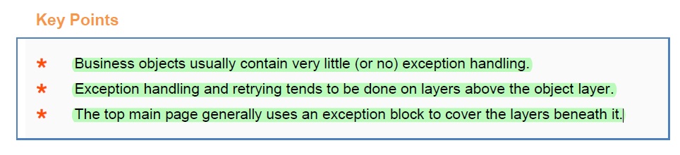
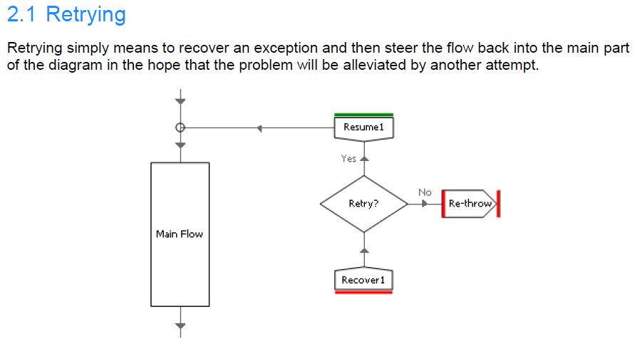
Retrying depends upon the type of exception and number of retries –
[Retry Count]<[Retry Limit] AND
(Lower(ExceptionType())="system exception" OR
Lower(ExceptionType())="internal")
you would not want to retry for Business or Try Once exceptions.

‘Preserve the type and detail of the current exception’ checkbox.

When this checkbox is ticked, the exception stage simple ‘re-releases’ the current exception and allows it to bubble upwards as if it had never been recovered in the first place.
When this checkbox is not ticked, the exception stage generates a new exception, and importantly, keeps the current exception alive. This means that by misusing the ‘preserve’ checkbox can lead to problems.
If Preserve is unchecked , Critically, the original exception - the one caught by the Recover stage - is still alive. And although this won’t appear to present a problem in this simple example, when this mistake is present in a more complex, multi-layer solution, unhandled ‘zombie’ exceptions like this will cause problems.
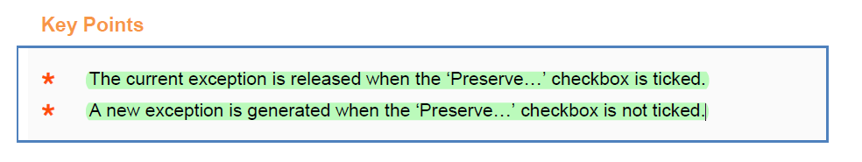
Remember that Resume stage neutralizes the exception and not Recover stage. Infinite loop possible only in Recover+Resume is used. Won’t happen when only recover is used as the exception is not neutralised and it will bubble up to main process.
If an exception stage marked as preserve exception is used outside the recover – resume block, then we get the below error
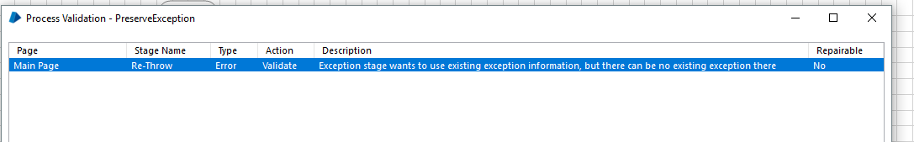

Adding Exception handling when casting data for Eg String assignment to a Date
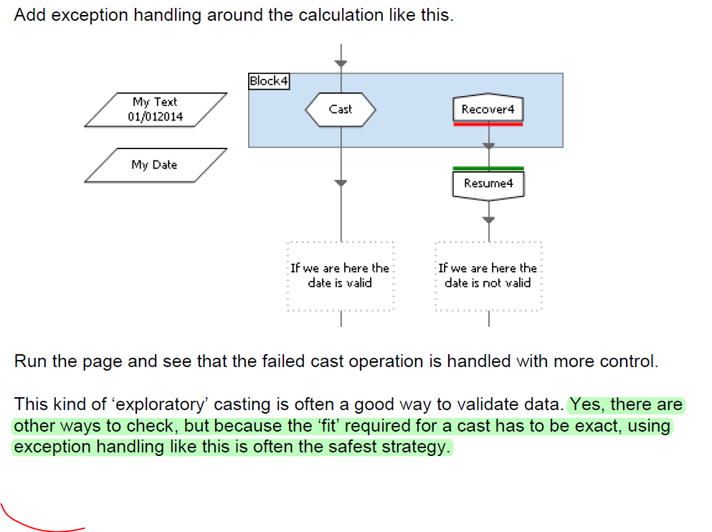
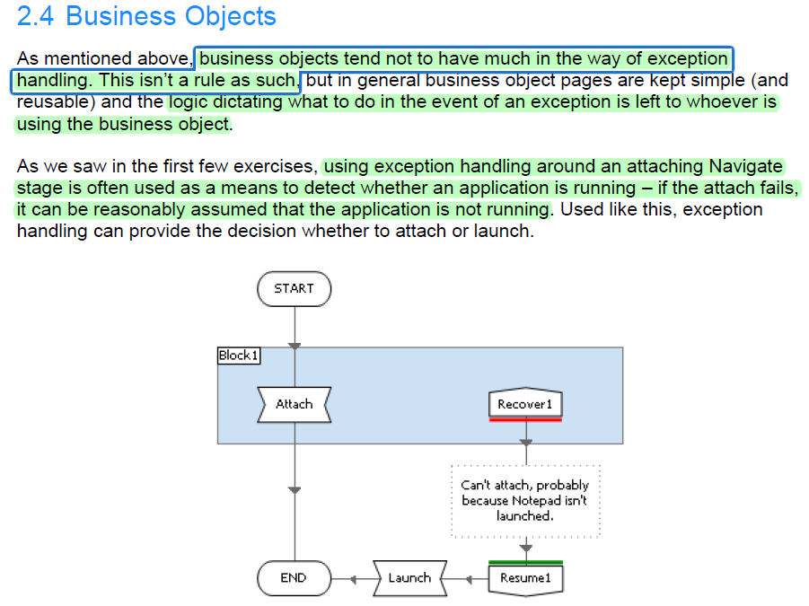

Passing Results as Exceptions
We should avoid throwing business exception when wait is timed out, instead we should check for all possible combinations in wait stage. It would then be a system exception as there could be issue with locator
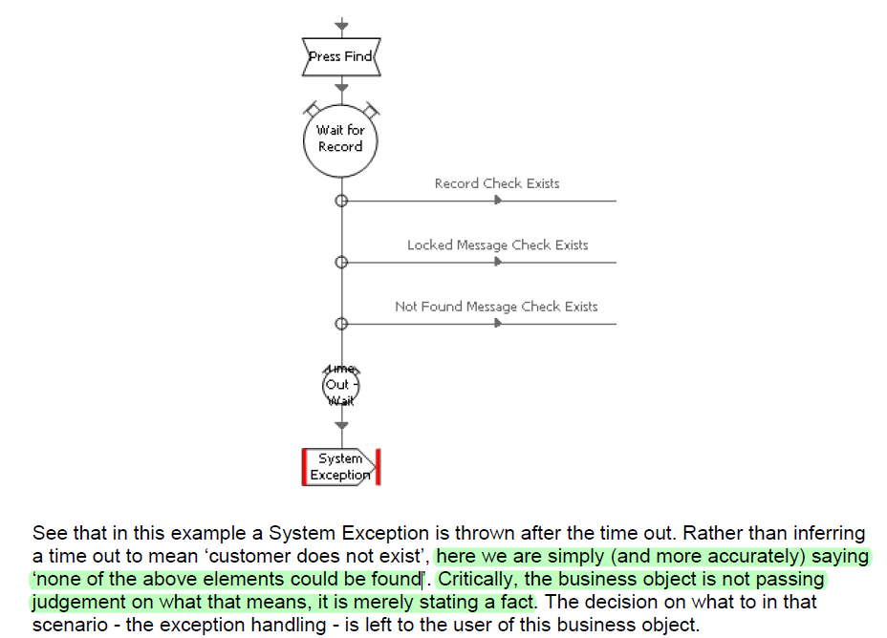
Avoid doing the below , Although this idea will work, consideration should be given to the impact is has on the users of the business object - anyone wanting to use this page must be aware of these potential outcomes and make provision for them.
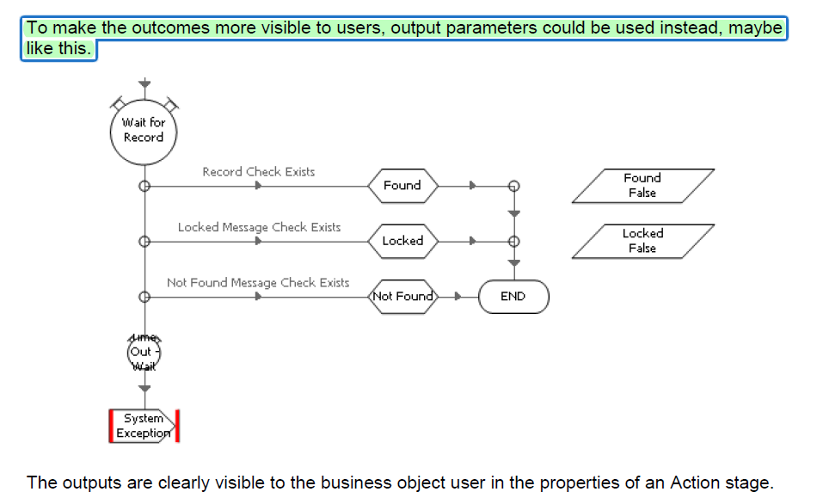
And because the outputs can only be True or False, the process logic using the Find Customer action is unambiguous.
In the below example, we are not using resume stage so exception if it comes will bubble up
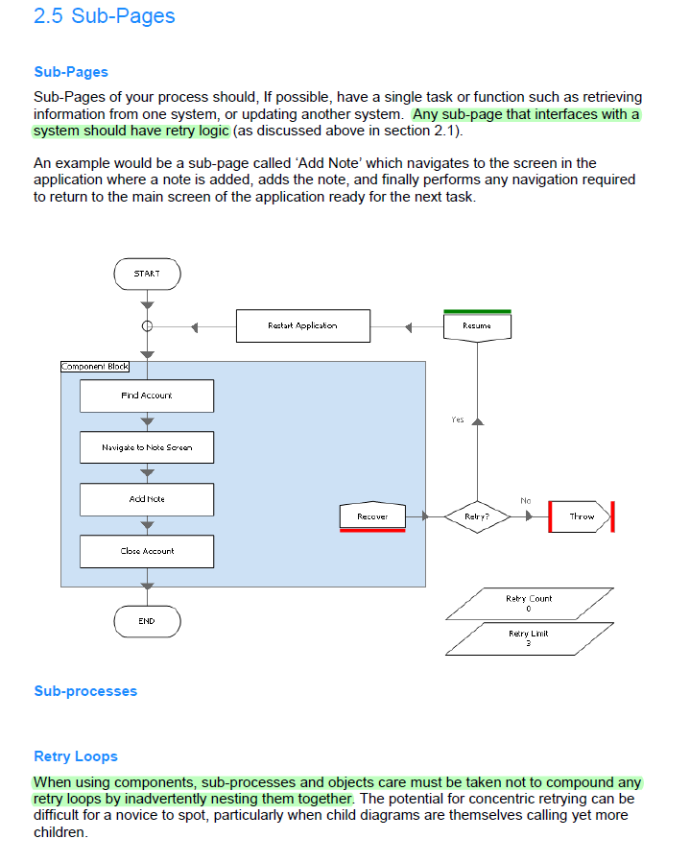
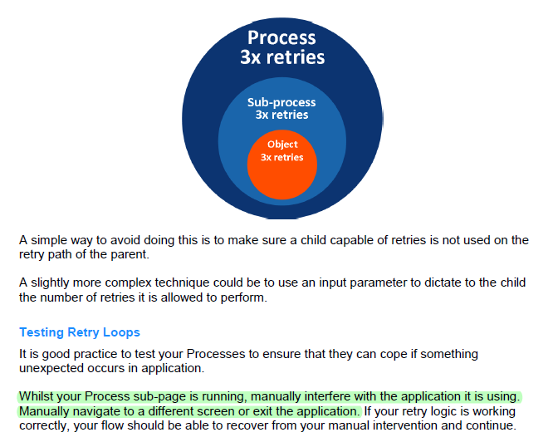
2.6 Processes
A process uses a queue to manage its workflow for
- As a place for new work
- Control distribution of cases to Resource PC
- To Store Results
Regardless to what happens to a queue item will its being worked upon, exception handling should be used to make sure queue is updated with the result
*See that these are sub pages inside the Main Block

But consider what would happen if the ‘Go back home’ stage failed.
The additional exception wouldn’t be handled and would terminate the process before the queue had been updated.
This would mean the queue item would be given the default (and rather unhelpful) exception
reason ‘automatically set exception at clean up’.
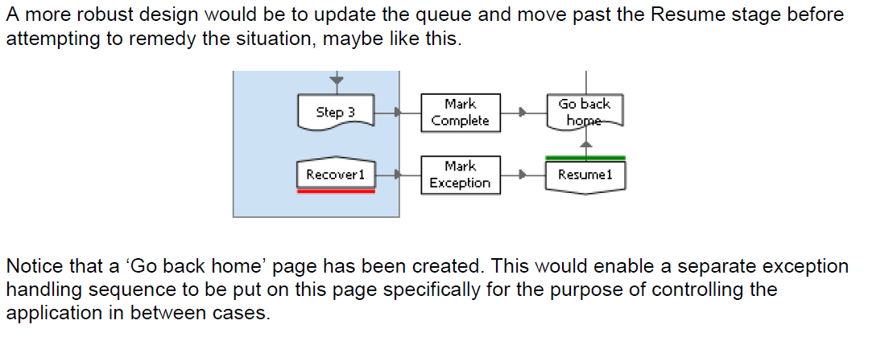

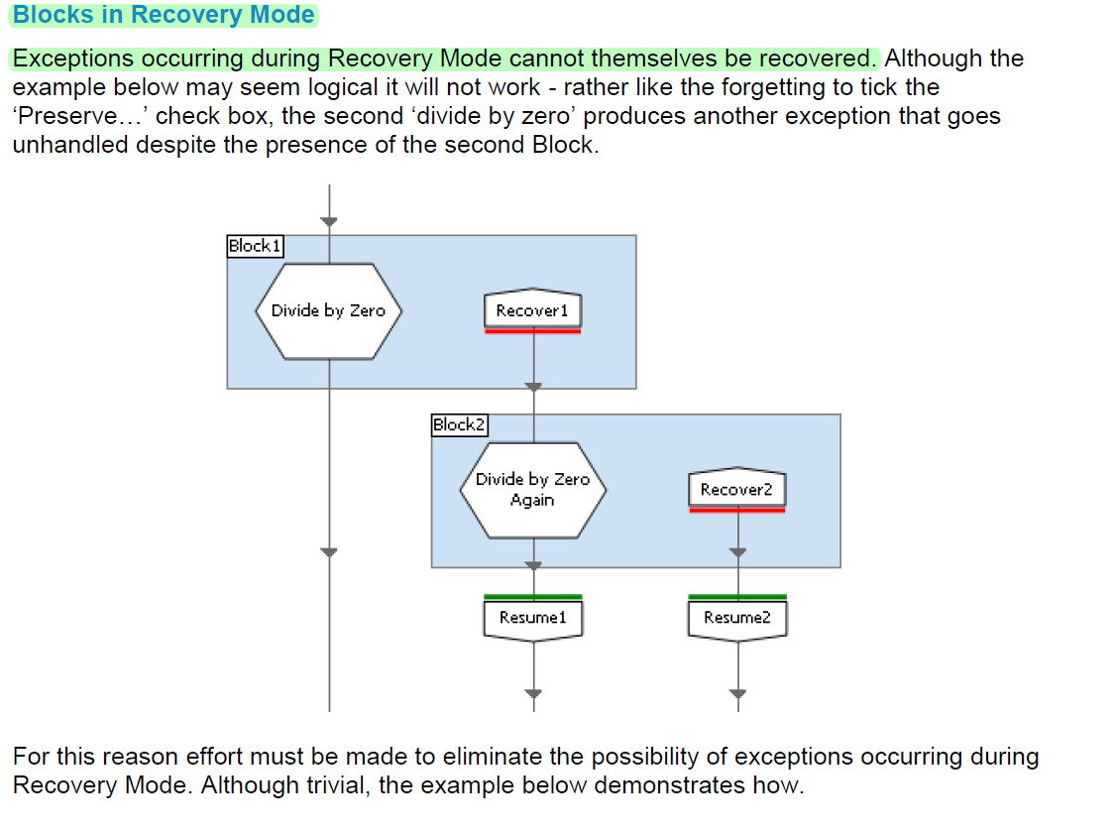
To avoid this place the Block 2 after resume stage
Notes
- The process execution always begins from main page. You cannot run sub pages
- (If Q is paused no items will be returned and throw an exception when we want to mark exception or mark complete saying Invalid ItemID)
- [Item ID] <> "" use this to check if item returned from queue

Exception Types
Basic –
- System Exception (Examples - timeouts)
- Business Exception (Juvenile Case)
Others –
- Validation Exception
- Data Exception (Invalid PatientID)

2.7 Queue Item Results
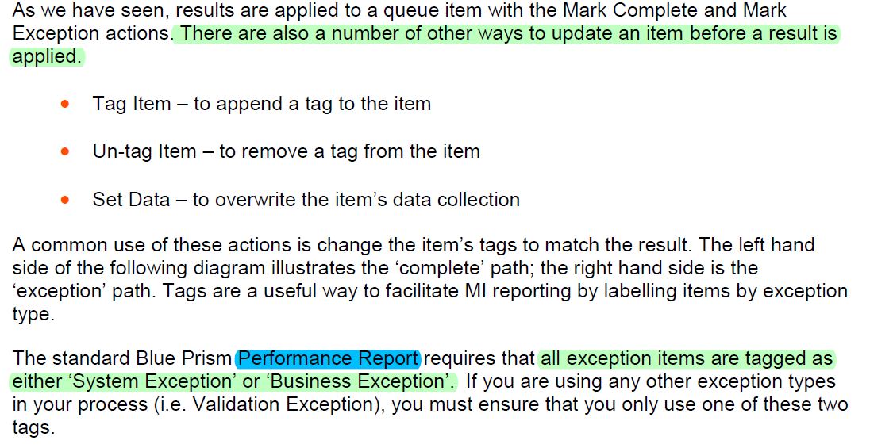

Monitoring Consecutive Exceptions
In the event of a serious problem with an application it may be better for a process to stop rather than carry on working. E.g. Application is down
- Throw System Unavailable Exception (from subpage or action)
- Unlock the item which was worked upon (Don’t mark it as exception)
- Notify the admin via email

Queue Item Retries
A work queue entry can be retried on Exception by using the flags Retry and Keep Locked input parameter of Mark Exception Action
If a new item is created, its ID will be returned in the New Item ID output parameter, and if Keep Locked was set to True, the process will have control of the new item.
Consideration should be given as to whether a new item should be worked immediately or whether it should be left unlocked (maybe for another machine to pick up) or even deferred for a while so as to provide a bit of ‘breathing space’ between items.
You will usually not require Queue Item Retries unless there is a unique design reason. All exception handling logic is usually done within your process (i.e. with retry loops) rather than using additional attempts on the Work Queue.

Retry | In | Flag | Whether or not to retry the item, up to the maximum number of attempts specified for the queue. Optional - if not specified, the item will be retried
New Item ID | Out | Text | The Item ID of the newly cloned item. This item will be locked if 'Keep Locked' is True. This will be empty if no item was cloned (ie. the item was not retried.

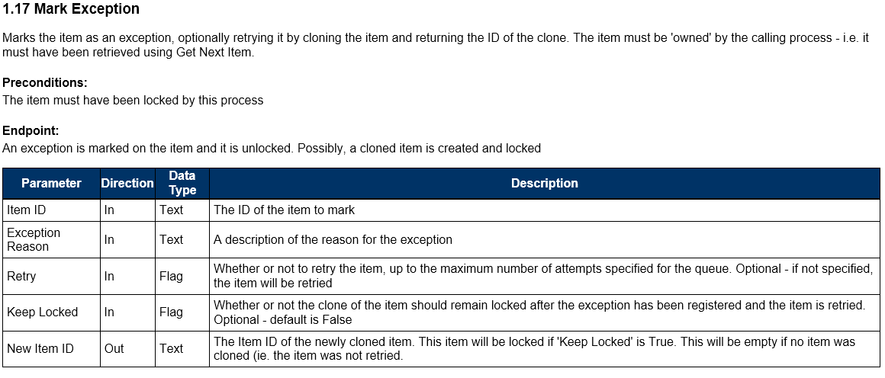
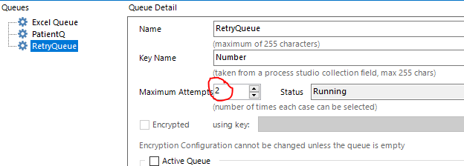

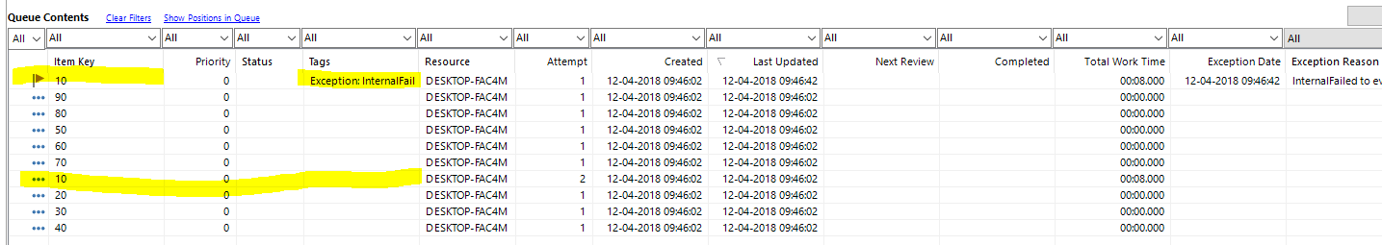
Blue prism internally takes care to not add the case again to queue if it fails the second time

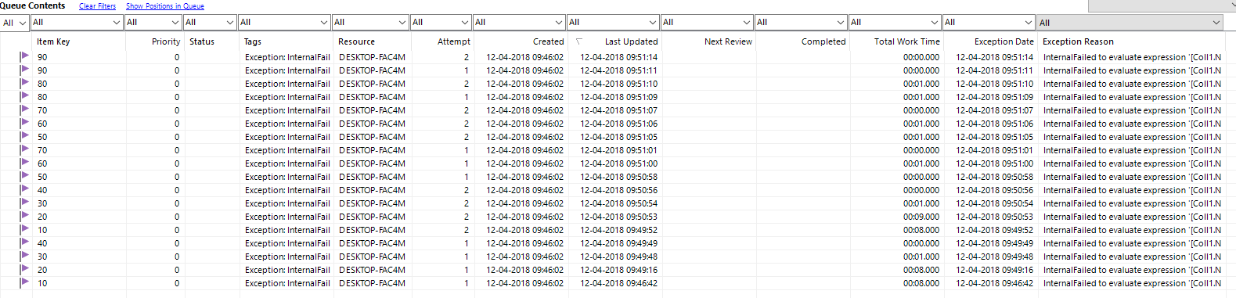

When Keep Locked is set to True
When we run the second time, since the item is blocked, it will throw “Invalid Item ID” exception when in the recovery block we try to “mark the exception as complete”

Updating an Exception Item
- Business Exception? --- > Move On To Next Item
- Abort Required? -- > Stop
- Consecutive Exceptions? -- > Stop
- Restart Required? -- > Restart App -- > Move On to Next
Each of these to have Notify Decision

Capturing Exception Details
It can be a good tactic to minimise the time spent in Recovery Mode by capturing the details of an exception in data items and then moving directly to the Resume stage. The advantage of doing this is that the risk of another exception occurring during Recovery Mode is eliminated

You can also use a multi calc stage for this

Exception Handling Infinite Loop.
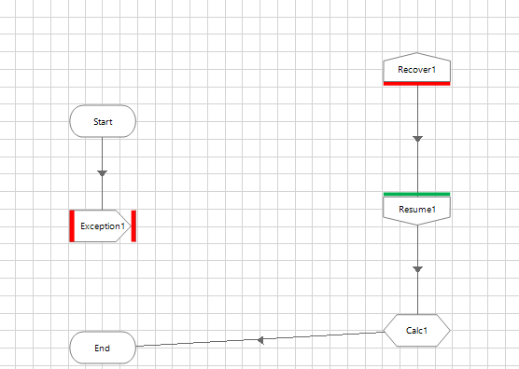
Occurs with some thing like this. Won’t happen if the Calc stage is just after the Recover block.
If we use resume stage. Old Exception gets killed and new exception can be handled by the recover stage.
If we add the calc stage after recover stage, and the calc stage throws an exception, then the old exception is not killed and the new exception which is generated will not be handled and it will be thrown by the process.

Human Intervention -
1) Problem did not occur in Mid Case
- Notify BP sys admin
2) Problem occurred in Mid Case
- Unexpected Termination? Notify Business and Admin
- Out of Scope Case? Check if Special Attention is required? (Notify Business of special/normal)
Check if High Frequency of out of scope cases (Notify Admin)

Unexpected Termination?
Normally a process will be configured with logic such as a ‘stop time’ to bring it to a natural completion. If a process terminates unexpectedly then there has been a problem which the Blue Prism system administrator should investigate.
Out-of-scope case?
If an exception case has been deemed out-of-scope in accordance with the solution design, then Blue Prism is working normally.
Special attention required for out-of-scope case?
The solution design may stipulate that some types of out-of-scope case require non-standard attention, perhaps because of an SLA (Service Level Agreement) or the unusual nature of the case. The normal notification procedure should be applied to all other out-of-scope cases.
Notify special out-of-scope case
Special cases may be announced in a different way to others, perhaps by sending an email to a particular mail box.
Notify normal out-of-scope case
The standard notification procedure for out-of-scope cases may simply be a report produced at the end of each day.
High frequency of out-of-scope cases?
The solution design should indicate the anticipated frequency of out-of-scope cases. If these cases appear more often than expected, then the BP system administrator should liaise with the Business to investigate the root cause.
Special attention required for in-scope case?
Some technical failures may be deemed more serious than others and necessitate particular interest.
Notify special in-scope case
If, for example, a target application hangs and consecutive system exceptions occur, the Blue Prism system administrators should be alerted
Notify normal in-scope case
As with normal out-of-scope cases, in-scope case may simply be announced via a report distributed to the stakeholders agreed in the design.
High frequency of in-scope cases?
Achieving a steady performance should be the goal of any Blue Prism solution. Exception levels are unlikely to be zero but they should at least be stable. Any jump in the failure rate is indicative of some sort of change that requires scrutiny from the Blue Prism system administrator.

